Harsh Goel

Sam Klein

Chris Rioux

Jeff Visk

**Conceptual Design Report**

Concept 1:

The first design will use a Klann mechanism to move the walker. The walker will be six legged with the legs moving in groups of three in a slow trot style gait. This will allow for three points of contact with the ground at all times as the slow trot has legs moving in two opposite groups with the suspension phase absent. It will produce a triangle over which the COM will travel. The walker will be driven with a gear on the D shaft of the motor. This will then drive two shafts (one on either side) where each shaft will drive 3 legs. The shafts will each have a driven gear of greater size than the drive gear. The result will be increased torque and lower rotations per minute for the legs. The initial position of each leg is what will decide when the leg is in contact with the ground. Two legs on one side and the center leg on the other will all be in phase, with the other group 180° offset. A 6 bar linkage resembling Stephenson’s mechanism would be used for the leg. The link lengths are shown below in figure 3. They were chosen to maximize the stride length while having it as steady as possible. This design has many advantages.Using 6 legs provides much needed stability to prevent the robot from tipping . It also will be able to traverse on uneven terrain. Challenges in creating this mechanism will mostly be centered around producing enough torque from the motor. The torque can be increased, but this will slow the rate that the robot moves at. The torque requirement will be high due to striding with 3 legs at a time. Another challenge will be created by having slow trot as the gait. It transitions between which legs are on the ground simultaneously which will be rough and possibly unbalanced. The linkage might need modifications to put them slightly out of phase. Tolerancing links will be important to preventing toggle points in the klann mechanism.

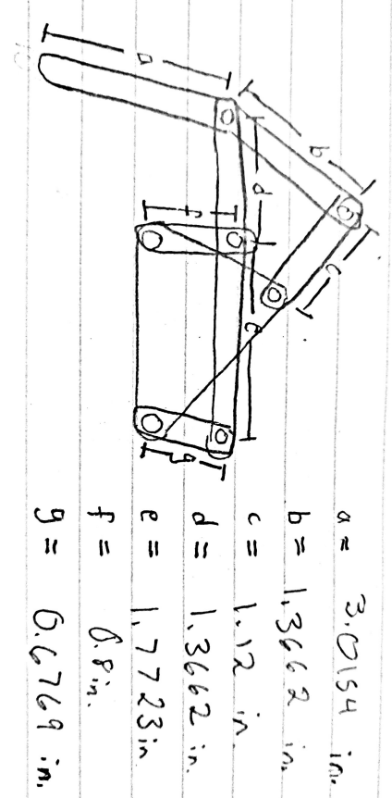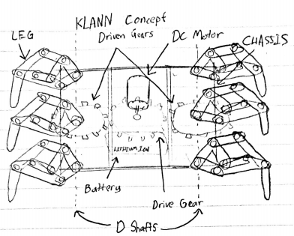



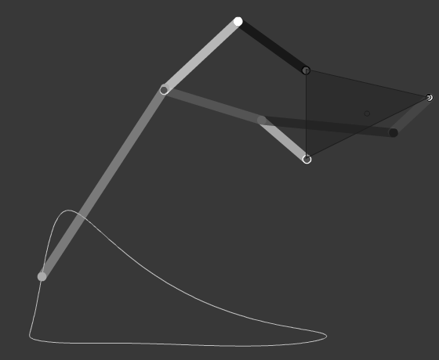

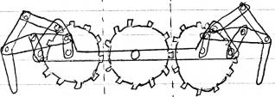





Concept 2:

The second design would use a Chebyshev’s plantigrade mechanism to drive the walker. The walker would have 4 legs moving in a slow trot walking gait where 2 legs would be in contact with the ground at a given time. The gait would have no suspension phase due to ensure stability of the robot and reduce spillage. As shown in Fig 4., a gear attached to the D shaft of the motor would be used to drive the crank shafts of the leg mechanism through 2 other gears. The initial positions of the cranks would determine which leg would be in the stance phase. The 2 legs on a given diagonal would be in the same phase, whereas the legs on the other diagonal would be at an offset of 180°. A 4 bar Grashof class 1 mechanism would be used for the legs as shown in Fig 6.. To ensure parallel motion with respect to the ground, a 2 bar cognate is added to the leg with a link extending towards the ground. The preliminary link lengths are shown in Fig 6. This robot could be used for traversing uneven terrain by changing the design of the feet. Due to lower number of legs, torque requirements would be lower and hence the robot’s walking speed is expected to be faster. However, due to 4 legs and slow trot mechanism, the robot may face stability issues. As 2 legs are in contact at a given time, one can expect a slight swaying in the robot which may lead to water spillage. To prevent swaying of the robot, appropriate dimensioning with slightly tighter margin of tolerancing is required. Another challenge would be the design of the feet to make the transition from a flat terrain to an inclined terrain smoother. 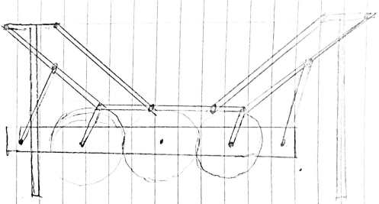

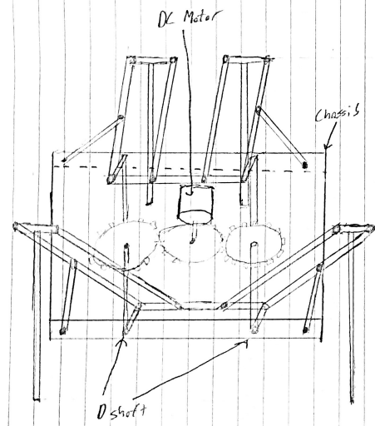 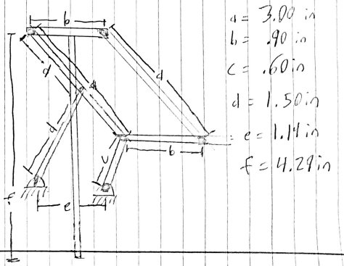





**Selected Design**

Design 1 would be pursued for the project. Design 1 was chosen as it is expected to provide much more stability while walking. Due to the use of three legs in the gait, a higher margin of tolerancing can be provided without compromising stability; hence easing the assembly of the robot. Furthermore, the first design is more suited to navigating inclined and rough terrains.